# M5. The Network Layer

Explain VC/Datagram Networks, and any three of the following: IP, IP addressing, subnetmask, and NAT

## **VC Networks:**

Virtual Circuit, VC, comparable to a ***Circuit Switch network*** with virtual circuits.

Packages follow the same routes and same sequence they were sent.

Ensures that the receiver is ready for the packages, since it requires a recite for a hand-shake package before sending the data packages.

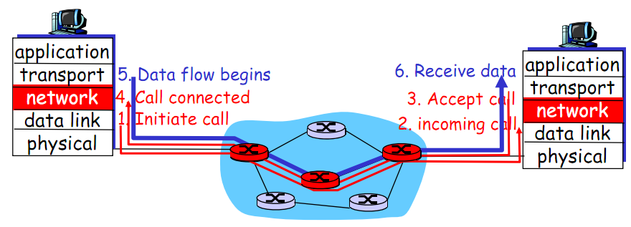

## Datagram networks:

Package = a message formated as a package  
Datagram = packages with unreliable serivce

A transport unit which is connected to a package-switched network, where delivery and sequence isn’t ensured.

A datagram consists of a header and data area, where the header consists of the information necessary to route from one host to another, without being dependant on previous exchanges between hosts.

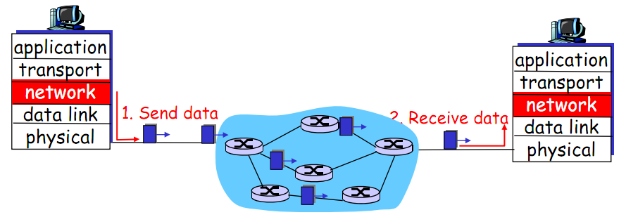

## IP

An IP is a 32-bit identifier for host router interfaces

## IP addressing

Either hardcode one, in windows under configuration/TCP IP/Proterties

Or get one dynamically where the host connects to a server and receives the IP-address from it. (Plug and Play)

1. Host broadcast
2. DHCP responds
3. Host requests IP address
4. DHCP server sends address

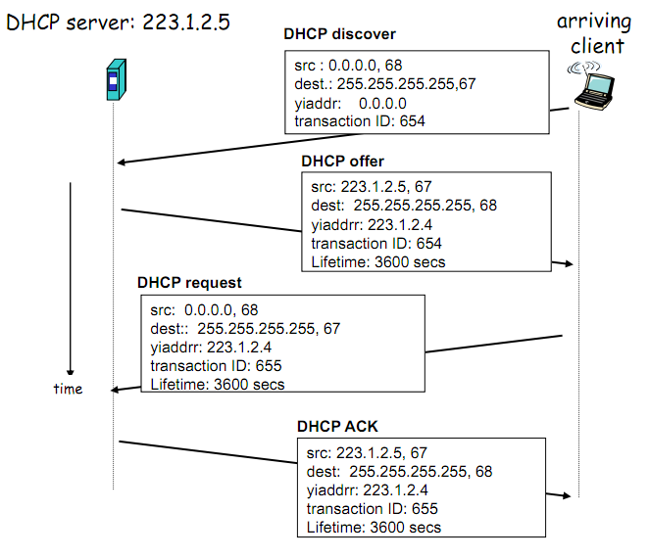

## Subnet mask

In the IP address 223.1.2.4/24, the subnet mask is 24 indicating that the 24 leftmost bits of the IP address denotes the subnet.

*To determine the subnets, detach each interface from its host or router, creating islands of isolated networks, with interfaces terminating the end points of isolated networks. Each of these isolated networks is called a subnet.*